**AI LAB-2**

1. **Solve 8 puzzle problem =>output**

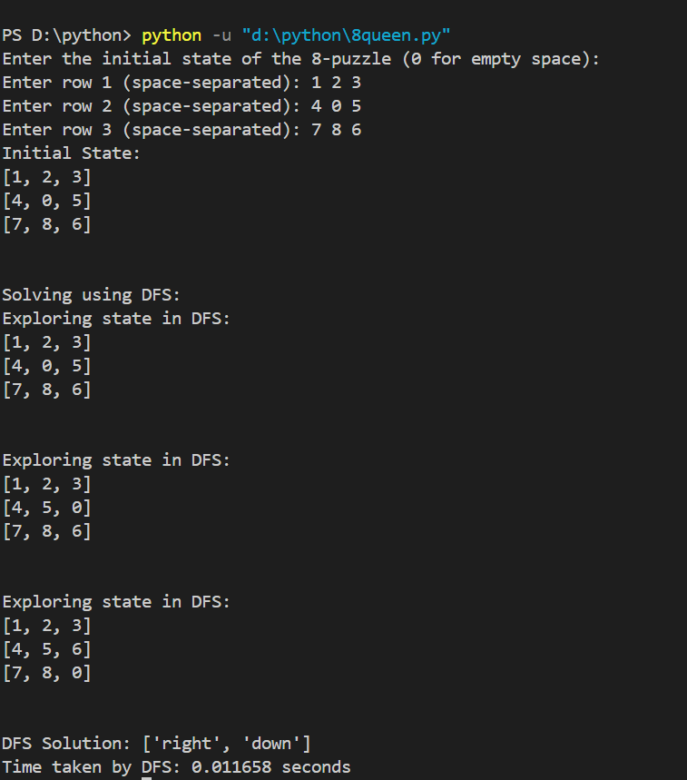

**2.Implemet Iterative deepening search algorithm**

